

Semester Two Examination, 2018

Question/Answer booklet

MATHEMATICS

SOLUTIONS
SPECIALIST
UNITS 3 AND 4

Section Two:

Calculator-assumed

Student number: In figures

In words

Your name

Time allowed for this section
Reading time before commencing work: ten minutes
Working time: one hundred minutes

Materials required/recommended for this section
To be provided by the supervisor
This Question/Answer booklet
Formula sheet (retained from Section One)

To be provided by the candidate
Standard items: pens (blue/black preferred), pencils (including coloured), sharpener,
correction fluid/tape, eraser, ruler, highlighters

Special items: drawing instruments, templates, notes on two unfolded sheets of A4 paper, and up to three calculators approved for use in this examination

Important note to candidates
No other items may be taken into the examination room. It is your responsibility to ensure that you do not have any unauthorised material. If you have any unauthorised material with you, hand it to the supervisor before reading any further.

Structure of this paper

Section | Number of questions available | Number of questions to be answered | Working  time (minutes) | Marks available
Section One:  Calculator-free | 8 | 8 | 50 | 53
Section Two:  Calculator-assumed | 13 | 13 | 100 | 98
 |  |  |  | 151

Instructions to candidates

1. The rules for the conduct of examinations are detailed in the school handbook. Sitting this examination implies that you agree to abide by these rules.

2. Write your answers in this Question/Answer booklet.

3. You must be careful to confine your response to the specific question asked and to follow any instructions that are specified to a particular question.

4. Supplementary pages for the use of planning/continuing your answer to a question
have been provided at the end of this Question/Answer booklet. If you use these pages to continue an answer, indicate at the original answer where the answer is continued, i.e. give the page number.

5. Show all your working clearly. Your working should be in sufficient detail to allow your answers to be checked readily and for marks to be awarded for reasoning. Incorrect answers given without supporting reasoning cannot be allocated any marks. For any question or part question worth more than two marks, valid working or justification is required to receive full marks. If you repeat any question, ensure that you cancel the answer you do not wish to have marked.

6. It is recommended that you do not use pencil, except in diagrams.

7. The Formula sheet is not to be handed in with your Question/Answer booklet.

Section Two: Calculator-assumed 65% (97 Marks)
This section has thirteen (13) questions. Answer all questions. Write your answers in the spaces provided.

Working time: 100 minutes.

Question 9 (4 marks)
A sphere has diameter $AB$ where points $A$ and $B$ have position vectors $(2, 0, 3)$ and $(0, 8, 9)$ respectively.

(a) Determine the vector equation of the sphere. (2 marks)
Solution
$$\text{Centre}\left(\begin{matrix}1 \\ 4 \\ 6\end{matrix}\right) \text{and radius} \left|\left(\begin{matrix}-1 \\ 4 \\ 3\end{matrix}\right)\right|=\sqrt{26}$$

$$\left|r-\left(\begin{matrix}1 \\ 4 \\ 6\end{matrix}\right)\right|=\sqrt{26}$$

$$(\sqrt{26}≈5.1)$$
Specific behaviours
determines radius
✓ correct centre and vector equation

(b) State, with justification, whether the point $P$ with position vector $(-1, 1, 2)$ lies inside, outside or on the surface of the sphere. (2 marks)
Solution
$$\left|\left(\begin{matrix}-1 \\ 1 \\ 2\end{matrix}\right)-\left(\begin{matrix}1 \\ 4 \\ 6\end{matrix}\right)\right|=\sqrt{4+9+16}=\sqrt{29}$$

$$\sqrt{29}>\sqrt{26}⇒P \text{is outside sphere}$$

$$(\sqrt{29}≈5.4)$$
Specific behaviours
determines distance from centre
✓ correct conclusion

Question 10 (5 marks)
The region $R$ enclosed by the curves $y^{2}=ax$ and $x^{2}=8ay$, has an area of $1014$ square units.

Determine the value of the positive constant $a$.
Solution
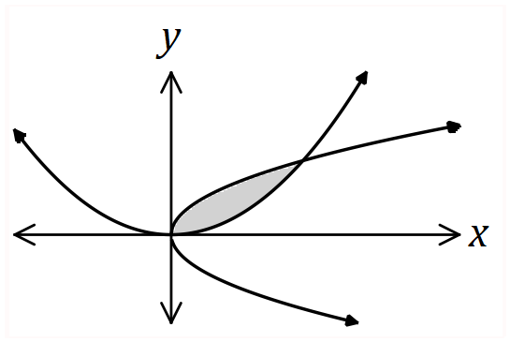

Intersect at $(0, 0)$ and $(4a, 2a)$ (CAS)

$$A=\int_{0}^{4a}{\left(\sqrt{a}\sqrt{x}\right)-\left(\frac{x^{2}}{8a}\right)}dx \\ =\frac{8a^{2}}{3}$$

$$\frac{8a^{2}}{3}=1014⇒a=\frac{39}{2}=19.5$$

Specific behaviours
sketches curves
✓ identifies points of intersection
✓ correctly formed integral
✓ evaluates integral in terms of $a$
✓ solves for $a$

CAS solution
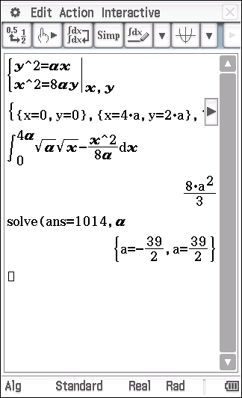

Question 11 (6 marks)
(a) Bags of lemons are packaged for sale by a supermarket. The population mean and standard deviation of the weight of the bags is known to be $1.05$ kg and $35$ g respectively.

Determine the probability that the total weight of a random sample of $45$ bags of lemons is greater than $47.5$ kg. (3 marks)
Solution
Let $\overline{W}$ be the distribution of random samples of size $45$ from the population.
Then $\overline{W}\sim N\left(1.05,\frac{{0.035}^{2}}{45}\right)\sim N\left({1.05, 0.00522}^{2}\right)$
$$P\left(\overline{W}>\frac{47.5}{45}\right)=0.1435$$

Specific behaviours
defines sample mean as a normally distributed rv
and indicates parameters of normal distribution
✓ indicates probability calculated
✓ correct probability

(b) The supermarket also packs bags of oranges for sale. The weights of the bags have a population mean and standard deviation of $μ$ and $σ$ kg respectively.

A random sample of $50$ bags was taken and used to construct a $90\%$ confidence interval for $μ$. If the interval was $(1.99, 2.04)$, determine an estimate for $σ$. (3 marks)
Solution
Margin of error: $\frac{2.04-1.99}{2}=0.025$

$$90\%⇒z=1.645$$

$$\frac{σ}{\sqrt{50}}×1.645=0.025$$

$$σ=0.107 \text{kg}$$

Specific behaviours
calculates margin of error
✓ uses correct $z$-score
✓ correct standard deviation

Question 12 (7 marks)
(a) A bifolium has equation ${\left(x^{2}+{3y}^{2}\right)}^{2}=16x^{2}y$.

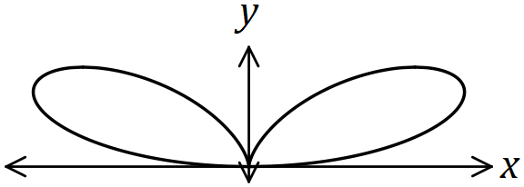

Show that the gradient of the bifolium at the point $(1, 1)$ is $\frac{1}{2}$. (4 marks)
Solution
$$2\left(x^{2}+3y^{2}\right)\left(2x+6yy^{'}\right)=32xy+16x^{2}y^{'}$$

$$x=1, y=1⇒2\left(1+3\right)\left(2+6y^{'}\right)=32+16y^{'}$$

$$16+48y^{'}=32+16y^{'}$$
$$32y^{'}=16$$
$$y^{'}=\frac{1}{2}$$

Specific behaviours
implicit diff of RHS
✓ implicit diff of LHS
✓ substitutes
✓ simplifies

(b) The gradient of a circle that passes through the point $(1, 2)$ is given by

$$\frac{dy}{dx}=\frac{1}{y}-\frac{x}{y}.$$

Determine the equation of the circle. (3 marks)
Solution
$$\int{y} dy=\int{\left(1-x\right)}dx$$

$$\frac{y^{2}}{2}=x-\frac{x^{2}}{2}+k$$

$$y^{2}=2x-x^{2}+c$$
$$c=2^{2}-2+1=3$$

$$x^{2}-2x+y^{2}=3$$

Specific behaviours
separates variables
✓ integrates
✓ correct equation, no specific form required

Question 13 (7 marks)
The position vector $r$ at time $t$ seconds of a small particle $P$ is shown below and given by

$$r\left(t\right)=(3\sin\left(t\right)-2\sin\left(3t\right))i+\left(3\cos\left(t\right)-2\cos\left(3t\right)\right)j \text{cm}.$$

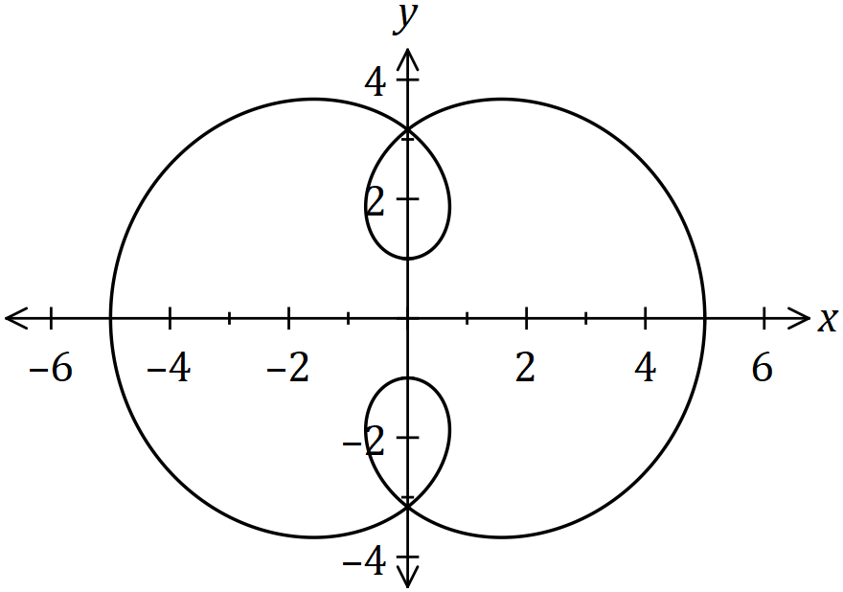

(a) Determine the change in displacement of $P$ between $t=0$ and $t=\frac{π}{2}$. (2 marks)
Solution
$$r\left(0\right)=j, r\left(\frac{π}{2}\right)=5i, ∆r=5i-j \text{cm}$$

Specific behaviours
determines positions
✓ states change

(b) Determine the velocity vector of $P$ when $t=\frac{π}{2}$. (2 marks)
Solution
$$v\left(t\right)=(3\cos\left(t\right)-6\cos\left(3t\right))i+\left(-3\sin\left(t\right)+6\sin{(3t)}\right)j \\ v\left(\frac{π}{2}\right)=-9j \text{cm/s}$$

Specific behaviours
differentiates to obtain velocity vector
✓ states velocity vector

(c) Determine the total distance travelled by $P$ until it first returns to its initial position.
(3 marks)
Solution
$$\text{Period is} 2π$$
$$d=\int_{0}^{2π}{\left|v\left(t\right)\right|}dt$$
$$=40.095 \text{cm}$$

Specific behaviours
determines time to return
✓ correct integral
✓ distance (that rounds to 40 cm).

Question 14 (8 marks)
The slope field for the differential equation $\begin{matrix}dy \\ \overline{dx}\end{matrix}=\begin{matrix}1 \\ \overline{5(y-2)}\end{matrix}$ is shown below.

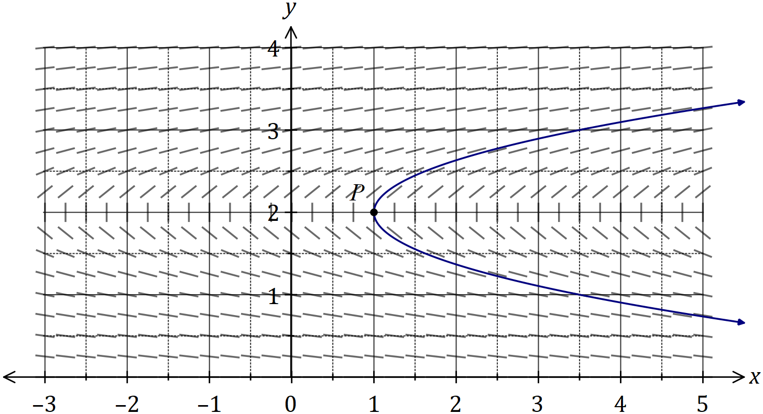
Solution (a)
See graph
Specific behaviours
through $\left(1, 2\right)$
✓ parabola, symmetrical about $y=2$

(a) Sketch the solution of the differential equation that passes through the point $P(1, 2)$.
(2 marks)

A different solution of the differential equation passes through the points $A(2, 3)$ and $B(2.1, b)$.

(b) Use the increments formula to estimate the value of $b$. (3 marks)
Solution
$$δx=\frac{1}{10}, \frac{dy}{dx}=\frac{1}{5(3-2)}=\frac{1}{5}$$

$$δy≈\frac{1}{5}×\frac{1}{10}≈\frac{1}{50}≈0.02$$

$$b≈3+0.02≈3.02$$

Specific behaviours
calculates gradient at $A$
✓ calculates $δy$ using increments formula
✓ correct estimate

(c) Calculate the value of the second derivative of the solution through $A$ and use it to explain whether your solution to (b) is an under or over estimate. (3 marks)
Solution
$$\frac{dy}{dx}=\frac{1}{5}{\left(y-2\right)}^{-1} \\ \frac{d^{2}y}{dx^{2}}=-\frac{1}{5}{\left(y-2\right)}^{-2}×\frac{dy}{dx} \\ =-\frac{1}{5}×\frac{1}{5}=-\frac{1}{25}$$

Curve is concave down, so will be an over estimate.

Specific behaviours
expression for second derivative
✓ correct value
✓ correct deduction

Question 15 (9 marks)
By using an appropriate substitution or the substitution provided, rewrite the following integrals in terms of $u$ and then evaluate algebraically.

(a) (5 marks)
Solution
Let
$$dx=\cos\left(u\right)du$$
$$x=0, u=0, x=5, u=π/2$$
Specific behaviours
trig substitution
relates $du$ and $dx$
✓ replaces bounds of integration
✓ simplifies to 1
✓ evaluates

(b) $\int_{1}^{7}{\underset{ }{\overset{ }{\begin{matrix}2x \\ \overline{\sqrt{2x+2}}\end{matrix}}}}dx$, using $u=\sqrt{2x+2}$. (4 marks)
Solution
$$u^{2}=2x+2⇒2u du=2 dx⇒u du=dx$$

$$x=1, u=2; x=7, u=4$$

$$I=\int_{1}^{7}{\frac{2x}{\sqrt{2x+2}}} dx \\ =\int_{2}^{4}{\frac{u^{2}-2}{u}} u du \\ =\int_{2}^{4}{u^{2}-2} du \\ ={\left[\frac{u^{3}}{3}-2u\right]}_{2}^{4}=\frac{44}{3}$$

Specific behaviours
relates $du$ and $dx$
replaces bounds of integration
simplifies integrand in terms of $u$
evaluates

Question 16 (10 marks)
A random sample of 50 households in Sydney were selected as part of a study on winter gas consumption. The mean winter consumption was 550 megajoules (MJ) of gas each week. In a very large study the previous year, it was found that the standard deviation of winter gas consumption was 105 MJ per week.

- Calculate a 90% confidence interval for the mean weekly winter gas consumption of households in Sydney. Leave answers correct to the nearest MJ. (3 marks)
Solution
Specific behaviours
Calculates z score
Correct Interval
Rounds Correctly

- A liberal party spokesman claimed that mean winter gas consumption of households in Sydney was 510 MJ per week. What is the minimum confidence level required if we were to use the sample above to support her claim? (2 marks)
Solution
Specific behaviours
Calculates z score
Correct Confidence
- 30 similar studies are planned for Sydney.

- Determine the least number of households that should be sampled in each of these studies to be 95% confident that the mean winter gas consumption of households in Sydney is within 20 MJ of the true value. (3 marks)
Solution
Specific behaviours
Calculates z score
Correct formula
Rounds Up
- How many of the 95% confidence intervals from these additional studies are expected to contain the true mean? Justify your answer. (2 marks)

Solution
Specific behaviours
Calculates correctly
Justifies
Question 17 (7 marks)
A company recently introduced a new electronic control device for homes. In one city, the number of households $H$, in thousands, that own the device $t$ months after observations began can be modelled by
$$H\left(t\right)=\frac{20}{1+3e^{-0.04t}}, t≥ 0.$$

(a) Use the model to determine

(i) the maximum number of households expected to own the device. (1 mark)
Solution
$$H\left(∞\right)=20⇒20 000 \text{households}$$

Specific behaviours
correct number

(ii) how long it will take for the number of households owning the device to double from the initial number. (2 marks)
Solution
$$H\left(0\right)=5⇒10=\frac{20}{1+3e^{-0.04t}}$$
$$t=27.5 \text{months}$$

Specific behaviours
initial number
✓ correct time

(b) Show that the rate of change of the population satisfies the equation $H^{'}\left(t\right)=kH(20-H)$ and determine the value of the constant $k$. (4 marks)
Solution
$$H=20{\left(1+3e^{-0.04t}\right)}^{-1} \\ H^{'}\left(t\right)=-20{\left(1+3e^{-0.04t}\right)}^{-2}\left(3e^{-0.04t}\right)\left(-0.04\right)$$

$$\text{But} 1+3e^{-0.04t}=\frac{20}{H}$$

$$H^{'}\left(t\right)=-20{\left(\frac{20}{H}\right)}^{-2}\left(\frac{20}{H}-1\right)\left(-0.04\right) \\ =\frac{0.04H^{2}}{20}\left(\frac{20}{H}-1\right) \\ =\frac{H}{500}(20-H)$$

$$k=\frac{1}{500} (≈0.002)$$

Specific behaviours
correct derivative of $H$
✓ substitutes for denominator of $H$
✓ systematic simplification
✓ value of $k$

Question 18 (10 marks)
Small bodies $P$ and $Q$ are initially at $A(3, -1, -4)$ and $C(5, 5, -6)$ respectively and are travelling with constant velocities.

One second later, $P$ and $Q$ are at $B(2, -2, -1)$ and $D(4, 3, -4)$ respectively.

(a) Determine the vector equation for the path of $P$ at any time $t$, where $t=0$ when $P$ is at $A$.
(2 marks)
Solution
$$\vec{AB}=\left(2, -2, -1\right)-\left(3, -1, -4\right)=\left(-1, -1, 3\right)$$

$$r_{P}=\left(3, -1, -4\right)+t\left(-1, -1, 3\right)$$

Specific behaviours
direction vector
✓ correct equation

(b) Show that the paths of $P$ and $Q$ cross, stating the point of intersection and explaining whether they also collide. (5 marks)
Solution
$$\vec{CD}=\left(4, 3, -4\right)-\left(5, 5, -6\right)=\left(-1, -2, 2\right)$$

$$r_{Q}=\left(5, 5, -6\right)+s\left(-1, -2, 2\right)$$

$$i \text{coeffs}:3-t=5-s$$
$$j \text{coeffs}: -1-t=5-2s$$

$$∴t=2, s=4$$

$$r_{P}\left(2\right)=\left(3, -1, -4\right)+2\left(-1, -1, 3\right)=(1, -3, 2)$$
$$r_{Q}\left(4\right)=\left(5, 5, -6\right)+4\left(-1, -2, 2\right)=(1, -3, 2)$$

Since $k$ coefficients are both $2$, then paths cross.

However, $P$ and $Q$ do not meet as they are at intersection at different times.

Specific behaviours
equation for path of $Q$
✓ equates $i$ and $j$ coefficients and solves for t
✓ checks $k$ coefficents for consistency
✓ states point of intersection
✓ states that paths cross, explains don't meet

(c) A third small body $G$ is stationary at the point $(7, 12, -8)$. Determine whether $G$ lies in the same plane as the paths of $P$ and $Q$. (3 marks)
Solution
$$n=\left(\begin{matrix}-1 \\ -1 \\ 3\end{matrix}\right)×\left(\begin{matrix}-1 \\ -2 \\ 2\end{matrix}\right)=\left(\begin{matrix}4 \\ -1 \\ 1\end{matrix}\right)$$

$$r∙n=\left(\begin{matrix}1 \\ -3 \\ 2\end{matrix}\right)∙\left(\begin{matrix}4 \\ -1 \\ 1\end{matrix}\right)=9$$

$$\left(\begin{matrix}7 \\ 12 \\ -8\end{matrix}\right)∙\left(\begin{matrix}4 \\ -1 \\ 1\end{matrix}\right)=28-12-8=8⇒\text{Not in same plane}$$

Specific behaviours
determines normal to plane
✓ determines equation of plane
✓ substitutes point and draws conclusion

Question 19 (10 marks)
The inner surface of a hemispherical bowl can be modelled by rotating part of the circle with equation $x^{2}+y^{2}=r^{2}, y≤0$, about the $y$ axis.

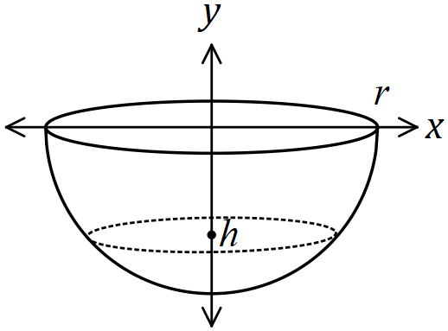

With the circular rim level, a liquid is poured into the hemisphere to a depth of $h$, measured from the bottom of the hemisphere, where $0≤h≤r$.

(a) Write a definite integral in terms of $r$, $h$ and $y$ for the volume of liquid in the bowl.
(2 marks)
Solution
$$V=\int_{-r}^{-r+h}{π\left(r^{2}-y^{2}\right)}dy \left(=\int_{r-h}^{r}{π\left(r^{2}-y^{2}\right)}dy\right)$$

Specific behaviours
correct integrand and $dx$
✓ correct limits

(b) Use your answer to (a) to show that the volume of liquid in a bowl when it is filled to a depth $h$ is given by $\frac{1}{3}πh^{2}(3r-h)$. (3 marks)
Solution
$$V=π{\left[r^{2}y-\frac{y^{3}}{3}\right]}_{-r}^{-r+h} \\ =\frac{π}{3}\left[\left(3r^{2}(h-r)-{\left(h-r\right)}^{3}\right)-\left(3r^{2}(-r)-{\left(-r\right)}^{3}\right)\right] \\ =\frac{π}{3}[3r^{2}h-3r^{3}-\left(h^{3}-3h^{2}r+3hr^{2}-r^{3}\right)-\left(-3r^{3}+r^{3}\right)] \\ =\frac{π}{3}\left[3r^{2}h-3r^{3}-h^{3}+3h^{2}r-3hr^{2}+r^{3}+2r^{3}\right] \\ =\frac{π}{3}[-h^{3}+3h^{2}r] \\ =\frac{1}{3}πh^{2}\left(3r-h\right)$$

Specific behaviours
correct antiderivative and substitution of limits seen
✓ correct expansion of ${\left(h-r\right)}^{3}$ seen (or ${\left(r-h\right)}^{3}$)
✓ correct simplification seen

(c) A hemispherical bowl, with an internal radius of $30$ cm, is filled with water at a constant rate from empty to full in $500$ seconds. Determine the rate of increase of the depth of water at the instant the hemisphere contains $1 008π$ cm³ of water. (5 marks)
Solution
$$\frac{dV}{dt}=\frac{2}{3}π{\left(30\right)}^{3}÷500=36π {\text{cm}}^{3}/\text{s} (≈113.1)$$

$$V=1008π=\frac{1}{3}πh^{2}\left(3(30)-h\right)⇒h=6$$

$$\frac{dV}{dh}=π\left(2rh-h^{2}\right) \\ =π\left(2\left(30\right)\left(6\right)-6^{2}\right) \\ =324π (≈1018)$$

$$\frac{dh}{dt}=\frac{dh}{dV}×\frac{dV}{dt} \\ =\frac{1}{324π}×36π$$

$$\frac{dh}{dt}=\frac{1}{9} \text{cm/s }(=0.\overline{1})$$

Specific behaviours
✓ calculates $dV/dt$
calculates height
✓ calculates $dV/dh$
✓ uses chain rule
✓ correct rate

Question 20 (9 marks)
A particle moves with velocity $v$ in a straight line so that its acceleration $a$is given by

$$a=-0.4v^{2}, v>0.$$

Distances are measured in metres and times are in seconds. Initially the particle is at the origin ($x=0$) and has velocity $v=40$.

(a) Use integration techniques to show that $v=40e^{-0.4x}$ , where the velocity $v$ of the particle as a function of its displacement $x$.
(5 marks)
Solution
$$v\begin{matrix}dv \\ \overline{dx}\end{matrix}=-0.4v^{2}$$

$$\int{\frac{1}{v}}dv=\int{-0.4}dx$$

$$\ln\left|v\right|=-0.4x+c$$

$$v=ae^{-0.4x}$$

$$x=0, v=40⇒a=40$$

$$∴v=40e^{-0.4x}$$

Specific behaviours
uses required form of acceleration
✓ separates variables
✓ integrates
✓ writes in exponential form (attn to removal of absolute value)
✓ determines constant

(b) Use integration techniques to determine the particular solution to the differential equation found in (a).
(4 marks)
Solution
$$v=\begin{matrix}dx \\ \overline{dt}\end{matrix}=40e^{-0.4x}$$
$$\int{e^{0.4x}}dx=\int{40}dt$$
$$2.5e^{0.4x}=40t+c$$

$$x=0, t=0⇒c=2.5$$

$$x=2.5ln⁡(16t+1)$$

Specific behaviours
separates variables
integrates
determines c from initial conditions
expresses explicitly in terms of t

Question 21 (6 marks)
(a) Determine the cube roots of $4\sqrt{3}-4i$, giving roots in polar form $r\operatorname{cis}{θ}$ where $-π<θ≤π$.
(3 marks)
Solution
$$z^{3}=4\sqrt{3}-4i \\ =8\operatorname{cis}\left(-\frac{π}{6}\right)$$

$$z=2\operatorname{cis}\left(\frac{2nπ}{3}-\frac{π}{18}\right), n=-1, 0, 1$$

$$z_{1}=2\operatorname{cis}\left(\frac{11π}{18}\right), z_{2}=2\operatorname{cis}\left(-\frac{π}{18}\right), z_{3}=2\operatorname{cis}\left(-\frac{13π}{18}\right)$$

$$(Arg\left(z\right)=-130°, -10°, 110°)$$
Specific behaviours
expresses in polar form
✓ one correct root
✓ all 3 roots

(b) One of the cube roots of $4\sqrt{3}-4i$ is also a fourth root of $w$.

If $ϕ$ is the argument of a fourth root of $w$ that lies in the first quadrant $\left(0≤ϕ≤\frac{π}{2}\right)$, determine all possible values of $ϕ$. (3 marks)
Solution
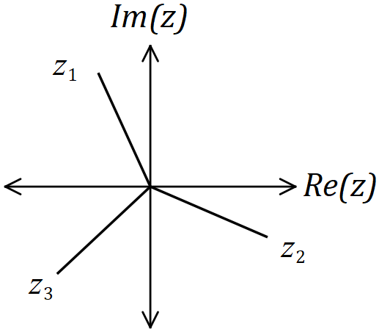

$w$ has four roots evenly spaced at $\frac{π}{2}$, one of which is either $z_{1}, z_{2}, \text{or} z_{3}$.

$$z_{1}-\frac{π}{2}⇒ϕ=\frac{π}{9}, z_{2}+\frac{π}{2}⇒ϕ=\frac{4π}{9}, z_{3}+π⇒ϕ=\frac{5π}{18}$$

$$(ϕ=20°, 40°, 80°)$$
Specific behaviours
sketch of cube roots
✓ one correct value
✓ all possible values

Supplementary page

Question number: _________

Supplementary page

Question number: _________

© 2018 WA Exam Papers. Hale School has a non-exclusive licence to copy and communicate this document for non-commercial, educational use within the school. No other copying, communication or use is permitted without the express written permission of WA Exam Papers. SN035-124-4.

